

Write your name below:

_______________________________________________

**Hale School**

**Year 11 Semester 1 Examination, 2015**

**Mathematics   
Methods**

**Teacher:__________________________**

**Section Two:  
Calculator-assumed  
  
Booklet 3 of 3**

TIME ALLOWED FOR THIS SECTION

Reading time before commencing: Ten minutes  
Working time for paper: One hundred minutes

**MATERIAL REQUIRED/RECOMMENDED FOR THIS PAPER**

*TO BE PROVIDED BY THE SUPERVISOR*

**TWO** Question/Answer booklets for Section Two – complete BOTH.

Formula Sheet (retained from Section One).

*TO BE PROVIDED BY THE CANDIDATE*

*Standard Items*: pens (blue/black preferred), pencils (including coloured), sharpener,   
 correction fluid/tape, eraser, ruler, highlighters

*Special Items*: drawing instruments, templates, notes on one unfolded sheet of A4 paper, and   
 calculators approved for use.

**IMPORTANT NOTE TO CANDIDATES**

No other items may be taken into the examination room. It is your responsibility to ensure that you do not have any unauthorised notes or other items of a non-personal nature in the examination room. Please check carefully, and if you have any unauthorised material with you, hand it to the supervisor **BEFORE** reading any further.

**STRUCTURE OF THIS PAPER**

|  |  |  |  |  |  |
| --- | --- | --- | --- | --- | --- |
| Section | Number of questions available | Number of questions to be answered | Working time (minutes) | Marks available | Percentage of exam |
| Section One:  Calculator-free | 9 | 9 | 50 | 50 | 37 |
| Section Two:  Calculator-assumed | 15 | 15 | 100 | 85 | 63 |
|  | | |  | **Total** | 100 |

**INSTRUCTIONS TO CANDIDATES**

1. Write your answers in this Question/Answer Booklet.
2. You must be careful to confine your responses to the specific questions asked and to follow any instructions that are specific to a particular question.
3. Spare pages are included at the end of this booklet. They can be used for planning your responses and/or as additional space if required to continue an answer.

● Planning: If you use the spare pages for planning, indicate this clearly at the top of the page.

● Continuing an answer: If you need to use the space to continue an answer, indicate   
 in the original answer space where the answer is continued, i.e. give the page number.

1. Fill in the number of the question that you are continuing to answer at the top of the page.
2. Show all your working clearly. Your working should be in sufficient detail to allow your answers to be checked readily and for marks to be awarded for reasoning. Incorrect answers given without supporting reasoning cannot be allocated any marks. For any question or part question worth more than two marks, valid working or justification is required to receive full marks. If you repeat any question, ensure that you cancel the answer you do not wish to have marked.
3. It is recommended that you do not use pencil, except in diagrams.

Section Two: Calculator Assumed 85 marks (63%)  
This section has 15 questions. Answer all questions. Write your answers in the spaces provided.  
Working time: 100 minutes  
_______________________________________________________________________________

**Question 18 7 marks**

In this situation, the Universal set is the set of **positive integers less than or equal to 15** and contains the subsets:

$A=set of even numbers$

$B=set of prime numbers$

$C=\{2, 5, 7, 10, 12, 13\}$

1. List the elements of set $A∪C$. (1 mark)
2. Determine $|\overline{C}|$ (1 mark)

1. Determine $n(A∩B)$ (1 mark)
2. Is the statement $5∈A$ true or false? Justify your answer. (2 marks)
3. Is the statement $C$ ⊂ $(A∪B)$ true or false? Justify your answer. (2 marks)

**Question 19 5 marks**

The Venn diagram below shows the probabilities for sets B and C.



1. If a number from $U$ is chosen at random, determine: (3 marks)

$P(B)$

$P(\overline{B∪C})$

$P(C|B)$

Set A is added to the Venn diagram as shown below.



1. If a number from $U$ is chosen at random, determine: (2 marks)

$P(A∩B∩C)$

$P(A∪B∪C)$

**Question 20 5 marks**

Hanna was using her calculator to determine a function that modelled the temperature $T$ (in $°C$) on one day last summer. Her temperature function was

$T =-0.01t^{3} + 0.266t^{2} -0.957t+ 21.77$.

The function applied from midnight ($t = 0$) to midnight ($t = 24$).

1. The graph of the temperature function for the 24 hour period is shown below. Label the coordinates of all key features on the graph, correct to 2 decimal places. (3 marks)

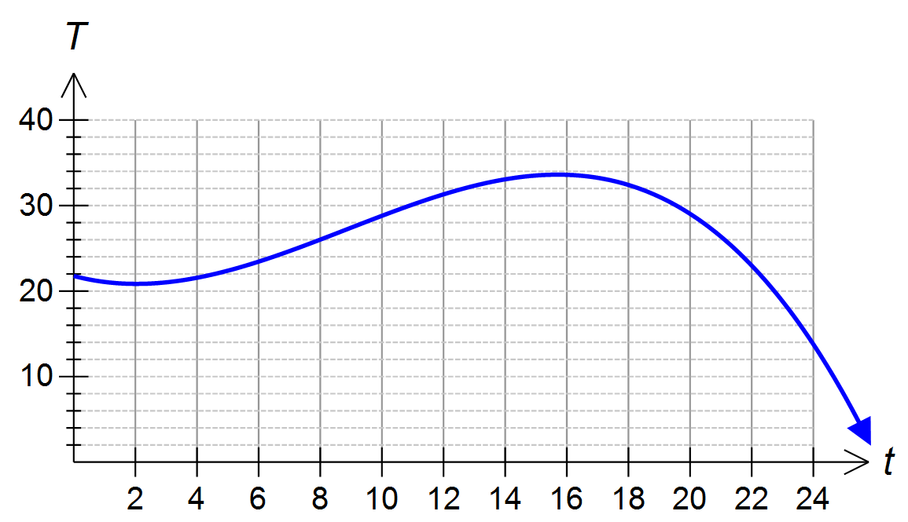

1. What did Hanna’s function suggest the temperature was at 5:00 pm? (2 marks)  
   Answer accurately to 3 decimal places.

**Question 21 7 marks**

1. The probabilities for two events A and B are found to be $P\left(A\right)=0.35$, $P\left(B\right)=0.2$ and $P\left(A|B\right)=0.6$. Determine: (4 marks)

$P\left(A∩B\right)$

$P\left(A∪B\right)$

1. Two events, D and E, are defined such that $P\left(D\right)=0.6$, $P\left(D∩E\right)=x$ and $P\left(\overline{D}∩E\right)=0.1$  
   .

Determine $x$ if sets *D* and *E* are independent. (3 marks)

**Question 22 5 marks**

Triangle PQR has a base of $(21 – 2 x) cm$ and perpendicular height of $x cm$, as shown in the triangle below.

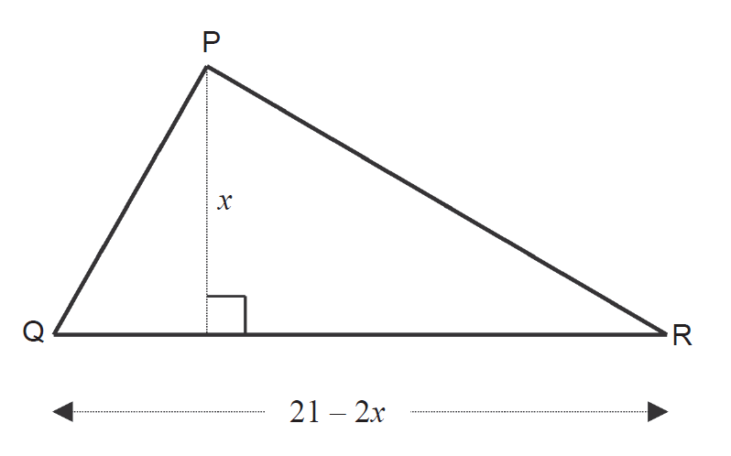

1. Determine an expression for the area function of the triangle in terms of $x$. (1 mark)
2. Sketch the area function below. Clearly label any intercepts or turning points. (3 marks)

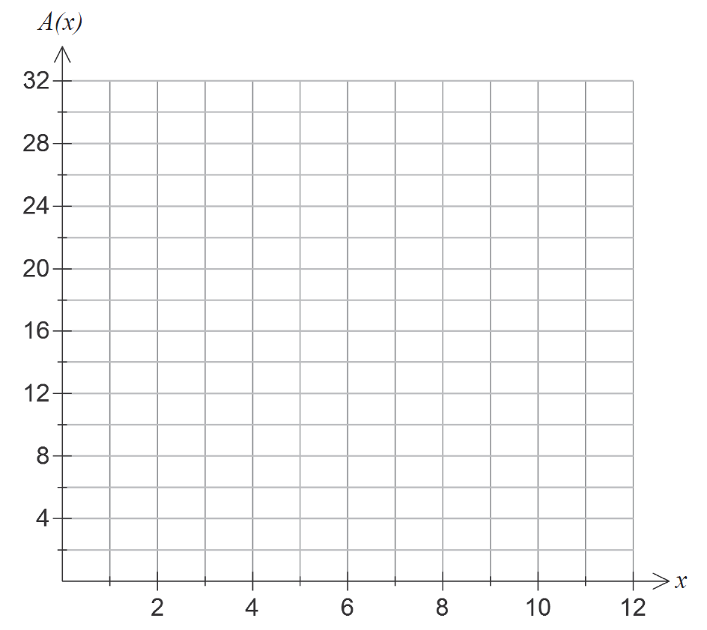

1. What is the maximum possible area of triangle PQR? (1 mark)

**Question 23 6 marks**

1. Triangle XYZ has side lengths $x=6 cm$, $y=10 cm$ and an area of $15\sqrt{3} cm^{2}$. Determine the size of $∠XZY$. (3 marks)
2. In the figure shown below, the arc BD is centred at A and has the same length as tangent segment BC. Show that the sector ABD will have the same area as the triangle ABC.

(3 marks)



**Question 24 7 marks**

The equation $x^{2} + y^{2} -2ky-2y { + k}^{2}+2k+1 =25$ represents a circle.

1. If the circle has a radius of $5 cm$, state the coordinates of the centre of the circle in terms of $k$. (4 marks)
2. If $k=3$, find the coordinates of the point(s) where the circle intersects the line $y=2x$.   
    (3 marks)

**END OF BOOKLET 3**

This page may be used for extra working space:

Question: ______

This page may be used for extra working space:

Question: ______

This page may be used for extra working space:

Question: ______